**Measurement of Planck’s Constant by Photoelectric Effect Experiment**

**MSc Lab Short Experiments**



**Submitted By,**

Sujoy Karmakar, DAA, [*sujoy.karmakar@tifr.res.in*](sujoy.karmakar@tifr.res.in)

 Reyhan Beheram Mehta, DNAP, [*reyhan.mehta@tifr.res.in*](reyhan.mehta@tifr.res.in)

Rohit Shekhawat, DNAP, [*rohit.shekhawat@tifr.res.in*](rohit.shekhawat@tifr.res.in)

**Under the supervision of,**

Prof. S. S. Prabhu

**Experiment Date,**

November 07, 2024

* **Introduction:** The photoelectric effect, first observed in late 19th century, is the process by which electrons are emitted from a material when it absorbs light of sufficient frequency. In 1905, Albert Einstein proposed that light is quantized into photons, each with energy $E=hν$, explaining the effect. This work earned him the Nobel Prize in 1921 and provided a method to measure Planck's constant, a key constant in quantum mechanics.
* 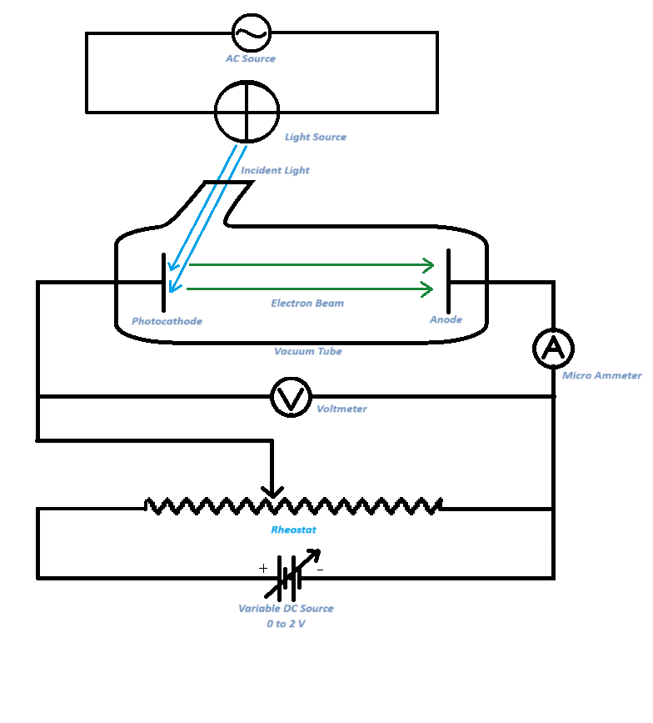**Theory and Working Principle:** When light with

sufficient frequency is incident on a metal surface,

there occurs ejection of electrons. When a setup

is made as shown in the image and the light is

incident on the photocathode, electron ejects from

it and moves toward the anode through the vacuum.

According to Einstein’s theory, the light is made of

Quantum of energy, called Photons each with

Energy $E=hν$ **.** The number density of photons in

the light increases with increment in the intensity.



In this setup we have showed the reversed bias

Mode. Here cathode is given to +ve voltage and

anode is given to -ve voltage. This voltage tries to

exactly equal to the numerical value of the kinetic

energy of the electron in eV units, there occurs no

Experimental Setup

electron flow to the anode and the current flow in

the circuit stops. The Einstein’s relation says,

$eV=hν+W_{0}$

$or, V=\frac{hc}{e λ }+\frac{W_{0}}{e}$**--------------------(1)**

Where V = Stopping potential, h = Planck’s constant, $ν$ = frequency of light, $λ$ = Wavelength of light,

W0 = Work function of the photocathode, e = charge of electron

* **Tasks:** Here in this experiment, we are goanna do,
  + Find the relation between the photocurrent and the applied potential in the reversed bias condition for constant intensity for multiple wavelengths of light.
  + Find the stopping potential for each wavelength and plot them.
  + From the slope of the stopping potential vs frequency graph, find the work function of the material and the Planck’s constant.
* **Apparatus**: The apparatus used for this experiment are,
  + Light source with different wavelength filters (405nm, 436nm, 546nm, 578nm)
  + Photocell for h-determination, with housing
  + Variable DC power supply 0~2 Volt range
  + AC power source
  + Multimeter (x2) (One as voltmeter and one as microammeter)
  + Connecting Wires
  + Rheostst
* **Experimental Data:**
* Table 1: Table for Variation of photocurrent with applied voltage for $λ= 405 nm$:

Zero error of the sensor current flow: i0 = 0.003 μA

|  |  |  |
| --- | --- | --- |
| Retarding Potential (V) (Volts) | Measured Photocurrent (i)  (µA) | Corrected Photocurrent (I = i - i0) (µA) |
| -1.300 | 0.003 | 0.000 |
| -1.265 | 0.004 | 0.001 |
| -1.250 | 0.004 | 0.001 |
| -1.200 | 0.005 | 0.002 |
| -1.150 | 0.006 | 0.003 |
| -1.100 | 0.007 | 0.004 |
| -1.050 | 0.010 | 0.007 |
| -1.000 | 0.012 | 0.009 |
| -0.950 | 0.016 | 0.013 |
| -0.900 | 0.021 | 0.018 |
| -0.850 | 0.027 | 0.024 |
| -0.800 | 0.035 | 0.032 |
| -0.750 | 0.045 | 0.042 |
| -0.700 | 0.056 | 0.053 |
| -0.650 | 0.068 | 0.065 |
| -0.600 | 0.083 | 0.080 |
| -0.550 | 0.097 | 0.094 |
| -0.500 | 0.113 | 0.110 |
| -0.450 | 0.135 | 0.132 |
| -0.400 | 0.155 | 0.152 |
| -0.350 | 0.176 | 0.173 |
| -0.300 | 0.196 | 0.193 |
| -0.250 | 0.216 | 0.213 |
| -0.200 | 0.240 | 0.237 |
| -0.150 | 0.265 | 0.262 |
| -0.100 | 0.285 | 0.282 |
| -0.050 | 0.305 | 0.302 |
| -0.025 | 0.317 | 0.314 |
| 0.000 | 0.326 | 0.323 |

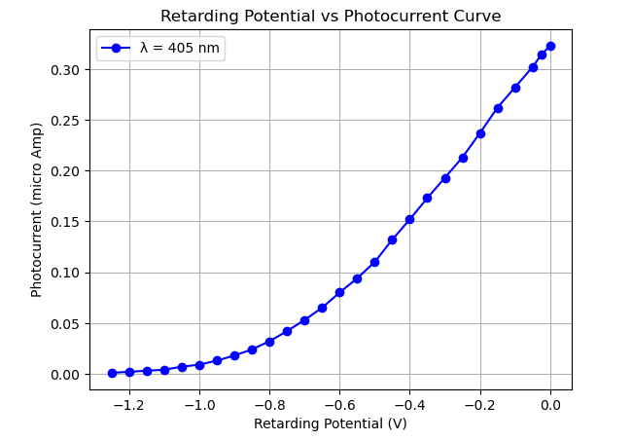

(I)

(Volts)

* Table 2: Table for Variation of photocurrent with applied voltage for $λ= 436 nm$:

Zero error of the sensor current flow: i0 = 0.000 μA

|  |  |  |
| --- | --- | --- |
| Retarding Potential (V) (Volts) | Measured Photocurrent (i)  (µA) | Corrected Photocurrent (I = i - i0) (µA) |
| -1.050 | 0.000 | 0.000 |
| -1.044 | 0.001 | 0.001 |
| -1.000 | 0.002 | 0.002 |
| -0.950 | 0.003 | 0.003 |
| -0.900 | 0.006 | 0.006 |
| -0.850 | 0.008 | 0.008 |
| -0.800 | 0.013 | 0.013 |
| -0.750 | 0.019 | 0.019 |
| -0.700 | 0.027 | 0.027 |
| -0.650 | 0.036 | 0.036 |
| -0.600 | 0.047 | 0.047 |
| -0.550 | 0.060 | 0.060 |
| -0.500 | 0.075 | 0.075 |
| -0.450 | 0.093 | 0.093 |
| -0.400 | 0.112 | 0.112 |
| -0.350 | 0.131 | 0.131 |
| -0.300 | 0.153 | 0.153 |
| -0.300 | 0.175 | 0.175 |
| -0.300 | 0.197 | 0.197 |
| -0.300 | 0.221 | 0.221 |
| -0.300 | 0.248 | 0.248 |
| -0.300 | 0.273 | 0.273 |
| -0.300 | 0.285 | 0.285 |
| -0.300 | 0.299 | 0.299 |

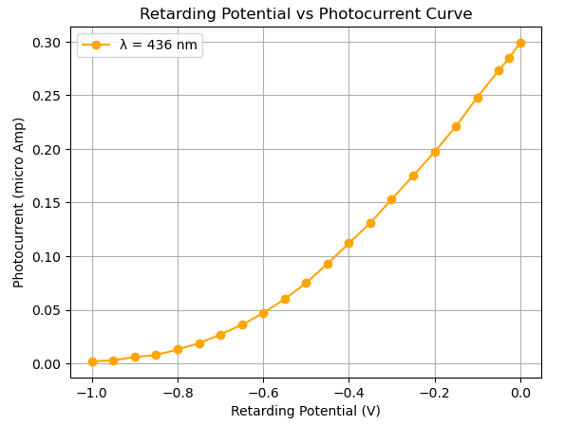

(I)

(Volts)

* Table 3: Table for Variation of photocurrent with applied voltage for $λ= 546 nm$:

Zero error of the sensor current flow: i0 = 0.000 μA

|  |  |  |
| --- | --- | --- |
| Retarding Potential (V) (Volts) | Measured Photocurrent (i)  (µA) | Corrected Photocurrent (I = i - i0) (µA) |
| -0.650 | 0.000 | 0.000 |
| -0.616 | 0.001 | 0.001 |
| -0.600 | 0.001 | 0.001 |
| -0.550 | 0.003 | 0.003 |
| -0.500 | 0.007 | 0.007 |
| -0.450 | 0.012 | 0.012 |
| -0.400 | 0.021 | 0.021 |
| -0.350 | 0.034 | 0.034 |
| -0.300 | 0.052 | 0.052 |
| -0.250 | 0.074 | 0.074 |
| -0.200 | 0.098 | 0.098 |
| -0.150 | 0.123 | 0.123 |
| -0.100 | 0.150 | 0.150 |
| -0.050 | 0.177 | 0.177 |
| -0.025 | 0.190 | 0.190 |
| 0.000 | 0.204 | 0.204 |

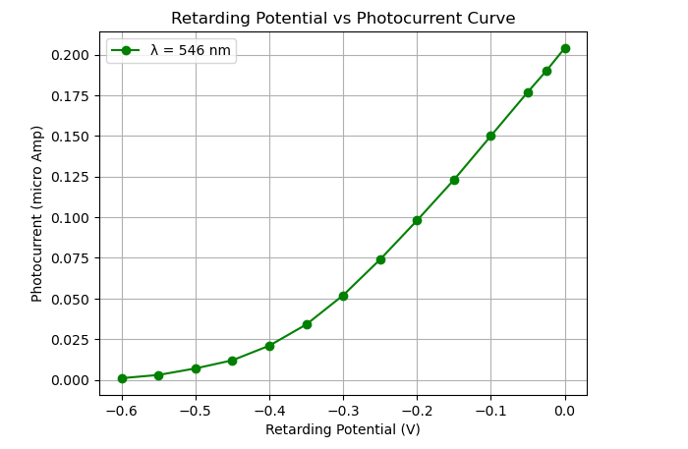

(I)

(Volts)

* Table 4: Table for Variation of photocurrent with applied voltage for $λ= 578 nm$:

Zero error of the sensor current flow: i0 = 0.002 μA

|  |  |  |
| --- | --- | --- |
| Retarding Potential (V) (Volts) | Measured Photocurrent (i)  (µA) | Corrected Photocurrent (I = i - i0) (µA) |
| -0.602 | 0.002 | 0.000 |
| -0.550 | 0.002 | 0.000 |
| -0.514 | 0.003 | 0.001 |
| -0.501 | 0.003 | 0.001 |
| -0.450 | 0.004 | 0.002 |
| -0.400 | 0.006 | 0.004 |
| -0.350 | 0.009 | 0.007 |
| -0.300 | 0.012 | 0.010 |
| -0.250 | 0.018 | 0.016 |
| -0.200 | 0.025 | 0.023 |
| -0.150 | 0.033 | 0.031 |
| -0.100 | 0.042 | 0.040 |
| -0.050 | 0.050 | 0.048 |
| -0.025 | 0.054 | 0.052 |
| 0.000 | 0.058 | 0.056 |

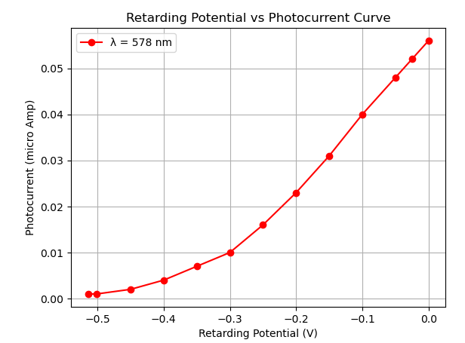

(Volts)

(I)

* Table 5: Table for Variation of stopping potential with frequency of light:

|  |  |  |
| --- | --- | --- |
| Wavelength $\left(λ\right)$ (nm) | Frequency (1014 Hz) | Stopping Potential (V0) (Volts) |
| 405 | 7.407 | 1.265 |
| 436 | 6.881 | 1.044 |
| 546 | 5.494 | 0.616 |
| 578 | 5.190 | 0.514 |

**Now, fitting the above data using linear least square fit method in python, we get the plot given below.**

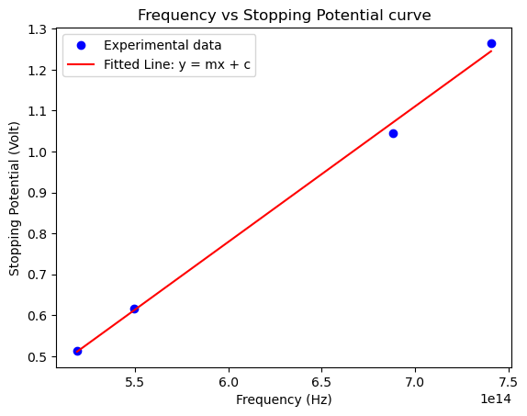

* The slope is: $3.310×{10}^{-15}$ **V s**
* The y intercept is: $-1.207$ **V**

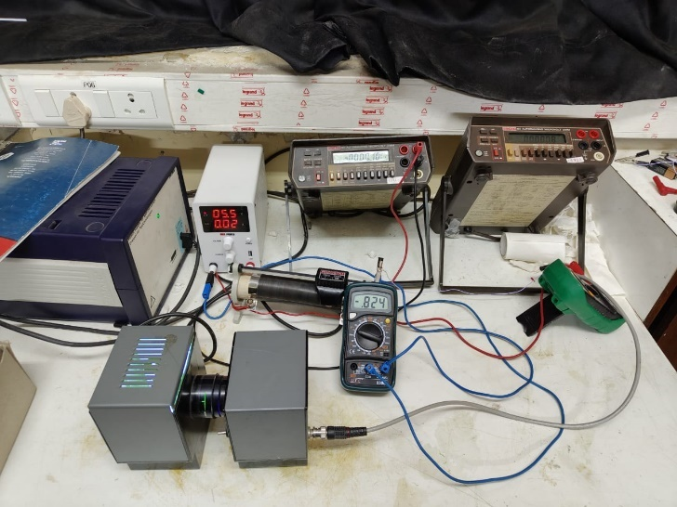

**Image of the setup taken during the Experiment**

* **Experimental Results:** After analysing the data, we get several quantities. They are given below. The data file and python code can be accessed by clicking on the link,

<https://github.com/Sujoy7471/Expt.Methods/tree/main/Photoelectric%20Effect>

* Obtained Value of Planck's Constant: $5.303×{10}^{-34}J·s$
* Work Function is:  **1.207 eV**
* Threshold Frequency is: $3.646×{10}^{14}Hz$
* Threshold Wavelength is: **822.787 nm**
* **Comments:** After doing this practical, the value of the Planck’s constant that we get is in the range $±20\%$ from the actual accepted value. The deviation that occurred is due to the uncertainty in all the measured quantities, as we can’t measure them with infinite precision. Also, the voltmeter doesn’t have infinite resistance and the ammeter also doesn’t have infinite conductance. The wires also have some resistance. The light is not perfectly monochromatic. The vacuum tube in the sensor has not ideal vacuum. The voltage sources are also not perfect. Also, there can be some human errors like error during taking readings. All combined caused the error in the obtained value.